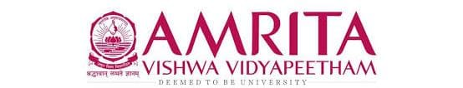

DATA STRUCUTRES AND ALGORITHMS

23CSE203

LAB MANUAL

Submitted by

Name | BANAVARAM DEEPTHIKA
Roll No | AV.SC.U4CSE25014
Year/Sem/Section | 2nd year/Sem-3/CSE-A
Credits | 05

Submitted to

Name | Dr. RAJ KUMAR BATCHU
Department | School of Computing
Designation | Asst. Professor (SI Grade)

S.NO | TITLE | PAGE NO | REMARKS
1. | WEEK 1: 1. Recursive countdown from n to Launch.  2. Recursive calculation of compound growth factor.  3. Recursive search for employee ID in list.  4. Recursive factorial calculation for parcel arrangements.  5. Recursive Fibonacci series generation. | 3 - 11
2. | WEEK 2: 1) write a python program to perform linear search on the given input.  2.a)write a python program to perform binary search on the given input verify by taking sorted array.  2.b) write a python program to perform binary search on the given input verify by taking unsorted array. | 12-18
3. | WEEK 3:
4. | WEEK 4:

LAB -1
1)AIM: A rocket launch system displays a countdown before launch. Instead of using a loop implement the countdown using recursion .write a recursion python program to display a countdown from n to 1 followed by “launch”.
PROGRAM:
def launch(n):
if n < 0:
print("invalid input")
else:
for i in range(n, -1, -1):
if i == 0:
print("launch")
else:
print(i)

n = int(input("Enter no. of seconds to launch: "))
launch(n)
OUTPUT:
Positive case:
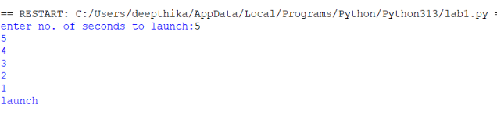
Negative case:
EXPLANATION:
This program displays a countdown from n to 1 and finally prints 'launch'. Although the aim mentions recursion, the given code uses a loop.
ERROR TABLE:
ERROR | CAUSE | SOLUTION
Indentation Error | Incorrect indentation | Align blocks properly
Name Error | Variable not defined | Define before use
Value Error | Non-integer input | Enter valid integer

2)AIM: banks calculate the growth of an investment using compound interest the formula requires calculating powers. Which can be implemented recursively. Write a recursive program to calculate p^n(power),where p=principal growth factor, n= number of years.
PROGRAM:
def intrest(p, n):
if n == 0:
return 1
elif n > 0:
return p * intrest(p, n - 1)
else:
return (1 / p) * intrest(p, n + 1)

n = int(input("Enter no. of years: "))
p = int(input("Enter a number: "))

res = intrest(p, n)
print(res)
OUTPUT:
Positive case:
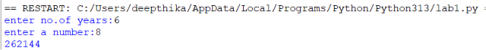
Negative case:
EXPLANATION:
This program recursively calculates p^n by multiplying p until n becomes 0.
ERROR TABLE:
ERROR | CAUSE | SOLUTION
Recursion error | Very large value of n | Reduce input
Name Error | Wrong function/variable name | Check spelling
Value Error | Non-integer input | Enter valid integer

3)AIM: An HR department stores employee ID’s in a list. Develop a recursive program to search for a given employee ID .write a recursive function to search for an employee ID in a list.
PROGRAM:
def search(m):

key=m
for i in range(n-1):
if arr[i]==key:
return i

n=int(input("enter no.of employees to add:"))
arr=[]
for i in range(n):
a=int(input("enter a value:"))
arr.append(a)
print(arr)
m=int(input("enter a element to search:"))
result=search(m)
if result==-1:
print(“element is not found”)
else:
print("employee id is stored at the index:",result)
OUTPUT:
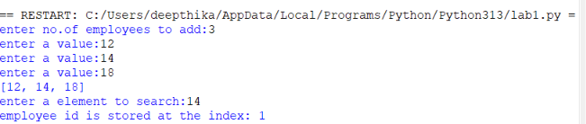
EXPLANATION:
This program searches for an employee ID in a list and returns its index if found.
ERROR TABLE:
ERROR | CAUSE | SOLUTION
Syntax error | Wrong quotes/brackets | Correct syntax
Logic error | Returns None instead of -1 | Return -1 when not found

4)AIM: In a logistics company the number of possible ways to arrange n different parcels is calculated using the factorial formula(n!). develop a recursive program to calculate the factorial of a given number.
PROGRAM:
def fact(n):
fact=1
if n<=0:
return "invalid input"
for i in range(1,n+1):
fact=fact*i

return fact
n=int(input("enter a number to find its factorial:"))
result=fact(n)
print(result)
OUTPUT:
Positive case:
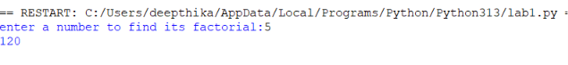
Negative case:
EXPLANATION:
This program calculates the factorial of a number using iteration (not recursion).
ERROR TABLE:
ERROR | CAUSE | SOLUTION
Overflow/large input | Large input value | Give smaller input
Value error | Invalid input | Even integer

5)AIM: write a recursive python program to print the first n terms of the Fibonacci series.
PROGRAM:
def fib(n):
if n==0:
return 0
elif n==1:
return 1
else:
return fib(n-1)+fib(n-2)

n=int(input("enter no of terms:"))
if n<=-1:
print("invalid input")
else:
for i in range(n):
print(fib(i),end=" ")
OUTPUT:
Positive case:
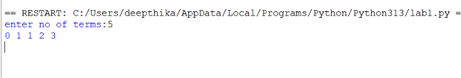
Negative case:
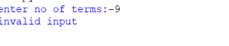
EXPLANATION:
The program uses recursion to generate Fibonacci numbers. fib (0)=0 and fib (1) =1 are the base cases. For every other term, fib(n)=fib(n-1) + fib(n-2). The loop prints the first n terms.

ERROR TABLE:
ERROR | CAUSE | SOLUTION
Recursion error | Large value of n | Use iteration
Invalid input | Negative value of n | Validate input
Slow execution | Repeated recursive calls | Use dynamic programming

PROGRAM | TIME COMPLEXITY | SPACE COMPLEXITY | REASON
1.countdown to launch | O(n) | O(1) | The program uses a loop that prints from n to 0 once.
2.power calculation | O(n) | O(n) | One recursive call is made for each value of n. The recursion stack stores n calls.
3.employee ID search | O(n) | O(1) | The program performs a linear search through the list.
4.Factorial | O(n) | O(1) | The program calculates factorial using a loop from 1 to n.
5.Fibonacci series | O(2ⁿ) | O(n) | Each function call creates two more recursive calls, leading to exponential time. The recursion stack reaches depth n.

Lab 2
1)AIM: write a python program to perform linear search on the given input.
Program:
def linear_search():
for i in range(n):
if list[i]==key:
return i
else:
return -1
list=[]
n=int(input("enter no of elements to add:"))
for i in range(n):
a=int(input("enter a number:"))
list.append(a)

print(list)

key=int(input("search element to find:"))
result=linear_search()
if result==-1:
print("element not found")
else:
print("element is found at",result)

Output:
Positive case:
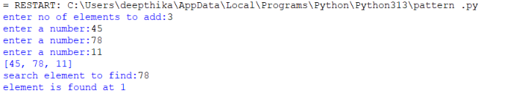
Negative case:
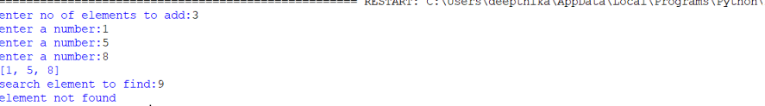
EXPLANATION:
This program performs a linear search by checking each element of the list one by one from the beginning. If the required key is found, its index is returned. If the key is not present, the program returns -1 and displays that the element was not found.
ERROR TABLE:
ERROR | CAUSE | SOLUTION
Name Error | Variable or function name is not defined or is misspelled. | Check the spelling and define the variable/function before use.
Value Error | A non-integer value is entered where an integer is required. | Enter a valid integer value.
Index Error | An invalid index is accessed. | Use an index within the valid list range.
Logic Error | The search condition or return statement is incorrect. | Check the comparison and return -1 when the key is not found.

2)AIM: a)write a python program to perform binary search on the given input verify by taking sorted array.
Program:
def binary_search(list,key,low,high):
if low>high:
return -1
else:
mid=(low+high)//2
if key>list[mid]:
return binary_search(list,key,mid+1,high)
elif key<list[mid]:
return binary_search(list,key,low,mid-1)
else:
return mid

list=[]
n=int(input("enter no of elements to add:"))
for i in range(n):
a=int(input("enter a number in sorted order:"))
list.append(a)

print(list)

key=int(input("search element to find:"))
result=binary_search(list,key,0,n-1)
if result==-1:
print("element not found")
else:
print("element is found at",result)
Output:
Positive case:
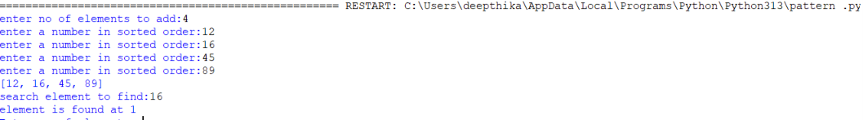
Negative case:
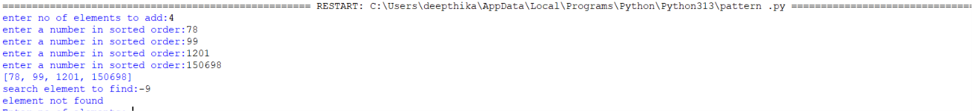
EXPLANATION:
This program performs binary search on a sorted array. It compares the key with the middle element. If the key is greater, it searches the right half; if the key is smaller, it searches the left half. The process continues recursively until the key is found or the search range becomes empty.
ERROR TABLE:
ERROR | CAUSE | SOLUTION
Value Error | A non-integer value is entered. | Enter valid integer values.
Logic Error | The input array is not sorted. | Enter the elements in sorted order.
Index Error | The low or high boundary is incorrect. | Use low = 0 and high = n - 1.
Recursion Error | The recursive boundaries are not updated correctly. | Use mid + 1 for the right half and mid - 1 for the left half.

2)AIM: b) write a python program to perform binary search on the given input verify by taking unsorted array.
Program:

def binary_search(list,key,low,high):
if low>high:
return -1
else:
mid=(low+high)//2
if key>list[mid]:
return binary_search(list,key,mid+1,high)
elif key<list[mid]:
return binary_search(list,key,low,mid-1)
else:
return mid

list=[]
n=int(input("enter no of elements to add:"))
for i in range(n):
a=int(input("enter a number:"))
list.append(a)

list.sort()
print(list)

key=int(input("search element to find:"))
result=binary_search(list,key,0,n-1)
if result==-1:
print("element not found")
else:
print("element is found at",result)
output:
positive case:
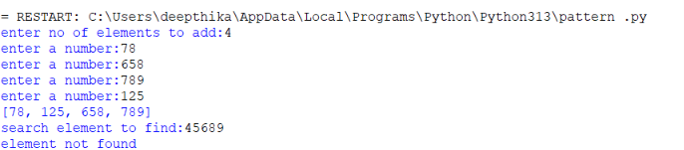
negative case:
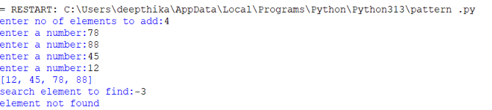
EXPLANATION:
This program accepts an unsorted array and first sorts it using the sort() method. After sorting, binary search is performed recursively on the sorted array. Sorting is necessary because binary search works only on ordered data.
ERROR TABLE:
ERROR | CAUSE | SOLUTION
Value Error | Invalid non-integer input is entered. | Enter valid integer values.
Logic Error | Binary search is performed without sorting the array. | Sort the array before calling binary_search().
Index Error | The initial search range is incorrect. | Pass low = 0 and high = n - 1.
Name Error | A variable or function name is misspelled. | Check all variable and function names.

TIME COMPLEXITY AND SPACE COMPLEXITY
PROGRAM | TIME COMPLEXITY | SPACE COMPLEXITY | REASON
1. Linear Search | O(n) | O(1) | The program checks the elements one by one. In the worst case, all n elements are checked, and no extra data structure is used.
2. Binary Search – Sorted Array | O(log n) | O(log n) | The search range is divided into half at every recursive call. The recursion stack stores the recursive calls.
3. Binary Search – Unsorted Array | O(n log n) | O(log n) | The array is first sorted using sort(), which takes O(n log n) time, followed by binary search in O(log n). The recursive search uses O(log n) stack space.

